PROJECT TITLE SHOULD BE IN UPPERCase LETTERS & TIMES NEW ROMAN

A PROJECT REPORT

BY

TEAM NO. 54

TEAM MEMBER1 (E17CSE001)

TEAM MEMBER2 (E17CSE002)

TEAM MEMBER3 (E17CSE003)

SUBMITTED TO

DEPARTMENT OF COMPUTER SCIENCE ENGINEERING BENNETT UNIVERSITY

GREATER NOIDA, 201310, UTTAR PRADESH, INDIA

NOVEMBER 2021

# DECLARATION

I/We hereby declare that the work which is being presented in the report entitled “Project Title”, is an authentic record of my/our own work carried out during the period from JUNE, 2020 to November, 2020 at Department of Computer Science and Engineering, Bennett University Greater Noida.

The matters and the results presented in this report has not been submitted by me/us for the award of any other degree elsewhere.

Signature of Candidate

Name of Teammate1

(Enroll. No. E17CSE001)

Name of Teammate2

(Enroll. No. E17CSE002)

Name of Teammate3

(Enroll. No. E17CSE003)

# ACKNOWLEDGEMENT

I/We would like to take this opportunity to express my/our deepest gratitude to my/our mentor, **Dr. IJKL (**Provide correct name & designation) for guiding, supporting, and helping me/us in every possible way. I/we was/were extremely fortunate to have him as my/our mentor as he provided insightful solutions to problems faced by me/us thus contributing immensely towards the completion of this capstone project. I/We would also like to express my/our deepest gratitude to VC, DEAN, HOD, faculty members and friends who helped me/us in successful completion of this capstone project. Any other name you can mentioned here. (Acknowledgement is your personal view, so you can write it in your way by maintaining integrity of technical report).

Signature of Candidate

Name of Teammate1

(Enroll. No. E17CSE001)

Name of Teammate2

(Enroll. No. E17CSE002)

Name of Teammate3

(Enroll. No. E17CSE003)

**TABLE OF CONTENTS**

<<Right click on the heading and click update flied. Your heading will be pulled here. Same goes with all the table of content in the subsequent pages>>

LIST OF TABLES vi

LIST OF FIGURES vii

LIST OF ABBREVIATIONS viii

ABSTRACT ix

1. INTRODUCTION 1

1.1. Problem Statement 1

2. Background Research 2

2.1. Proposed System 2

2.2. Goals and Objectives 2

3. Project Planning 3

3.1. Project Lifecycle 3

3.2. Project Setup 3

3.3. Stakeholders 4

3.4. Project Resources 4

3.5. Assumptions 5

4. Project Tracking 5

4.1. Tracking 5

4.2. Communication Plan 6

4.3. Deliverables 7

5. SYSTEM ANALYSIS AND DESIGN 8

5.1. Overall Description 8

5.2. Users and Roles 8

5.3. Design diagrams/ UML diagrams/ Flow Charts/ E-R diagrams 9

5.3.1. Use Case Diagrams 9

5.3.2. Class Diagram 10

5.3.3. Activity Diagrams 11

5.3.4. Sequence Diagram 12

5.3.5. Data Architecture 13

6. User Interface 14

6.1. UI Description 14

6.2. UI Mockup 14

7. Algorithms/Pseudo Code 15

8. Project Closure 16

8.1. Goals / Vision 16

8.2. Delivered Solution 16

8.3. Remaining Work 16

REFERENCES 17

LIST OF TABLES

Table Page

Table 1: Goal and Objectives 2

Table 2: Sample 2 3

Table 3: Sample 3 4

Table 4: Sample 4 4

Table 5: Sample 4 5

Table 6: Sample 6 5

Table 7: Regularly Scheduled Meetings 6

Table 8: Information To Be Shared Within Our Group 6

Table 9: Information To Be Provided To Other Groups 6

Table 10: Information Needed From Other Groups 7

Table 11: Deliverables 7

Table 12: Sample 12 8

LIST OF FIGURES

Figure Page

Figure 1: Sample use-case diagram 9

Figure 2: sample 2 11

Figure 3: sample 3 12

Figure 4: Sample 4 13

Figure 5: Sample 5 13

Figure 6: Sample 6 14

LIST OF ABBREVIATIONS

Abbreviation Explanation of the Abbreviation

AAA Authentication Authorization and Access Control

CSP Cloud Service Provider

DNS Domain Name System

IAM Identity and Access Management

ABSTRACT

Abstracts must use 250 words to 500 Basic guidelines for the preparation of a technical work for the project report. This document is itself an example of the desired layout (inclusive of this abstract) and can be used as a template. The document contains information regarding desktop publishing format, type sizes, and typefaces. Style rules are provided that explain how to handle equations, units, figures, tables, abbreviations, and acronyms. Sections are also devoted to the preparation of acknowledgments, references, and authors' biographies. The abstract is limited to 500 words and cannot contain equations, figures, tables, or references. It should concisely state what was done, how it was done, principal results, and their significance.

1. INTRODUCTION

<<Provide a brief overview of the current trends and situation around your project>>

Paragraph text paragraph text paragraph text paragraph text paragraph text paragraph text paragraph text paragraph text paragraph text paragraph text paragraph text paragraph text paragraph text paragraph text paragraph text paragraph text paragraph text paragraph text paragraph text paragraph text paragraph text paragraph text paragraph text paragraph text paragraph text paragraph text paragraph text paragraph text paragraph text paragraph text paragraph text paragraph text

* Bulleted list items use the “Bullets” style from the styles pane.
  1. Problem Statement

<< Provide a concise statement on the problem that currently exists and is affecting the organization/society/task.

Example: Currently, Microsoft uses Microsoft Dynamics AX as their enterprise resource planning (ERP) solutions for businesses. The latest version of Microsoft Dynamics AX will collect a significant amount of telemetry about the user’s actions while navigating in the application and its thousands of forms.>>

1. Background Research

<<Provide a detailed description of the literature research **(atleast 2 pages)** that you conducted around your project topic (make sure to cite the relevant sources in your text. E.g., research papers/web articles/blogs) and what motivated you, after researching, to work on the project.

Would suggest you to download a tool (Mendeley: [https://www.mendeley.com](https://www.mendeley.com/)) for automated citation and generation of references.>>

* 1. Proposed System

<< Provide a concise statement on the purpose of the project; the problem or opportunity addressed. The explanation should include what you intended to do. Vision – how will the customer’s world improve as a result of this project? When appropriate, tie this into what is currently being considered or has just been completed at the organization

Example: This project aims to extract information about how users use the forms by analyzing the raw telemetry data. By using big data analysis and machine learning techniques we hope to develop predictions into what actions the user will do next. Using these insights, the Microsoft Dynamics AX engineering may be able to optimize the user experience and reduce the number of steps needed to perform desired actions or reach desired forms.>>

* 1. Goals and Objectives

<< State, in quantifiable terms, if possible, the goals and objectives of the project. Goals may be related to product, process, quality, or teamwork. >>

**Example:**

<<to insert caption for tables and figures, click on references on the top menu, under captions section → click insert caption → choose label as table>>

Table 1: Goal and Objectives

|  |  |
| --- | --- |
| **#** | **Goal or Objective** |
| 1 | Make the system extensible – future updates like xxx can be done easily |
| 2 | Make the system easy to support – provide good documentation, configuration/build files, administrator’s manual |
| 3 | Make the system very easy to use – users would agree that minimal to no training is needed |
| 4 | Build a prototype that demonstrates the user interface by xx/xx/xx - in order to get early feedback from the customer/users |
| 5 | Have fun working on the project |

1. Project Planning

This section covers the details of the project planning. Selecting the lifecycle of the development, project stakeholders, resources required, assumptions made (if any) are detailed in the sections below.

* 1. Project Lifecycle

<< Describe the lifecycle of the project. You can choose from an existing lifecycle definition or create your own.

Example: The team will use an agile approach. Our team will gather requirements and create a high level development plan at the onset of the project and then implement the gathered requirements over three iterations. The team will follow a SCRUM-like approach with an emphasis on frequent meetings and collaboration.>>

* 1. Project Setup

<< Define some of the basic project decisions that will be used on this project. >>

**Example:**

Table 2: Sample 2

|  |  |
| --- | --- |
| **#** | **Decision Description** |
| 1 | Windows 8, C#, OpenSphere vs. Azure, Trac/SVN vs. Git, etc. |
| 2 | Standards that must be followed (default Capstone coding standard, etc.) |
| 3 | Special access privileges needed, nondisclosure forms, release to open source, etc. |
| 4 | A virtual server image will be set up at NDSU that matches the customer environment (image provided by customer) |

* 1. Stakeholders

<< Identify all stakeholders for this project (groups or individuals that are affected by or are in some way accountable for the outcome of the project – business managers, end users, developers, testers, support people, instructors, etc.) >>

**Example:**

Table 3: Sample 3

|  |  |
| --- | --- |
| **Stakeholder** | **Role** |
| Person A | Sponsor |
| Person B | Mentor |
| Person C | Instructor |
| Person D | Team member |
| Person E | Team member |
| Person F | Team member |

* 1. Project Resources

<< Identify the anticipated resources required for this project. This can include staff members who will work on the project, equipment needed for the project, special software that will need to be acquired, or any other resource necessary for the project. >>

**Example:**

Table 4: Sample 4

|  |  |  |
| --- | --- | --- |
| **Resource** | **Resource Description** | **Quantity** |
| Database Server | A database server provided by the sponsoring company. | 1 |
| Capstone Team | Our team of students who will be the primary developers of the project. | 4 |
| Jim Somebody | The mentor who will be able to provide us with technical assistance. | 1 |
| Mac Workstation | An OS X workstation with X Code for developing the OS X version of the software. | 1 |
| Android Phone | An Android phone to be used as test hardware for the mobile version of the software. | 2 |

* 1. Assumptions

<<State any assumptions upon which the project is based. Assumptions may be related to staffing, resources, tools, and schedules/deadlines. >>

**Example:**

Table 5: Sample 4

|  |  |
| --- | --- |
| **#** | **Assumption** |
| A1 | The capstone team and mentors will be able to meet face to face once a week. |
| A2 | Azure ML will be available for the team to work with as a trial for the first month of the project. |
| A3 | Team members will be able to familiarize themselves with the Azure ML, Azure HDInsights, and R environments |
| A4 | Team will have sufficient time to complete a working model to present by mid-semester |
| A5 | Machine Learning model will be completed in time to test on true big data using HDInsights and Hadoop |
| A6 | The development test data provided will be sufficient to create an accurate prediction of user actions |
| A7 | The models developed will be easily extended to other forms within the time frame |

1. Project Tracking
   1. Tracking

<< Provide information about how the project was tracked and where information was kept. This should include information such as what type of source control was being used and how it can be accessed, any bug-tracking system that was used for the project and where it can be accessed, what type of regressing testing suite was used and where it can be accessed, and any similar information that provides details on the project’s status, etc. >>

**Example:**

Table 6: Sample 6

|  |  |  |
| --- | --- | --- |
| **Information** | **Description** | **Link** |
| Code Storage | Project code will be stored in SVN repository. | Link |
| Bug Tracking | Bug tracking will be done with Trac. | Link |
| Project Documents and Assignments | Weekly reports, specification and design documents, etc. will be stored in our SVN repository. | Link |
| Continuous Integration | Continuous integration will be done with Jenkins. | Link |
| Regression Testing | Regression testing will use JUnit unit tests and Jenkins. | Link |

* 1. Communication Plan

<< Identify all communications you will provide to other groups and all communications you need to receive from other groups. Share this information with affected groups. Verify that all stakeholders are included. >>

Table 7: Regularly Scheduled Meetings

|  |  |  |
| --- | --- | --- |
| Meeting Type | Frequency/Schedule | Who Attends |
| Conference Call/Skype | Weekly | Project team and mentor |
| Team Meeting | Weekly | Project team |
| Short Meeting | Weekly in class | Project team |
| Sprint Planning Meeting | Start of each sprint | Project team and mentor |
| Sprint Retrospective Meeting | End of each sprint | Project team |
| Sprint Review Meeting | End of each sprint | Project team, ***mentor, and sponsor*** |

Table 8: Information To Be Shared Within Our Group

|  |  |  |  |
| --- | --- | --- | --- |
| Who? | What Information? | When? | How? |
| Project team | Task assignments & General scrum information | Weekly | Team meetings, listing in Project Specification. |

Table 9: Information To Be Provided To Other Groups

|  |  |  |  |
| --- | --- | --- | --- |
| Who? | What Information? | When? | How? |
| Sponsor and mentor | Final deliverables | At completion of project | Project specification doc., code, Power Point presentation |
| Sponsor and mentor | Weekly report | Weekly | Email and Trac site access |
| Sponsor and mentor | Project baselines ***(optional)*** | At the end of each sprint | Onsite customer demo, access to repository |

Table 10: Information Needed From Other Groups

|  |  |  |  |
| --- | --- | --- | --- |
| Who? | What Information? | When? | How? |
| Sponsor and mentor | Requirement changes | Start of each sprint | Conference call or meeting with sponsor and mentor. |
| Nathan Olson | Availability of test server | Start of second sprint | Email |

* 1. Deliverables

<< Identify the major deliverables that this project is expected to produce. Assume the deliverables apply to all features or stories listed above unless indicated otherwise. Deliverables may include prototypes, documentation, software, etc. >>

Table 11: Deliverables

|  |  |
| --- | --- |
| **#** | **Deliverable** |
| 1 | Study results ***(if any)*** |
| 2 | Code |
| 3 | Test and test results |
| 4 | Build process documents***(if any)*** |
| 5 | Install process documents***(if any)*** |
| 6 | Administrator or user manual***(if any)*** |
| 7 | Postmortem document |
| 8 | Final report (final PowerPoint presentation, 3 minute video, and final sprint) |

1. SYSTEM ANALYSIS AND DESIGN

This section describes in detail about the design part of the system.

* 1. Overall Description

This project is an attempt to create a useful social platform for communication which is exclusive to members of a certain organization. We have tried to create something similar to reddit.com but with some changes. As part of the prototype, we have created BB which is exclusive only to Bennett University students. First, users must sign-up on the website using their college email id which will be verified. Only after signing up they are able to see the posts and interact with them.

Bennett Bulletin (BB) is a website-based application where the students of Bennett University can freely share their experiences and stories without any fear. This platform is inspired by Reddit but is exclusive to Bennett University students. During this pandemic, it has become very difficult for students to interact with each other. Bennett Bulletin will help them to make connections which will be beneficial in the long run. With BB, we aim to build a community of people with similar interests during these difficult times.

* 1. Users and Roles

|  |  |
| --- | --- |
| **User** | **Description** |
| Developer | People responsible for creation of the website, android app and ios app. They are also responsible for constant updates to these systems and make sure that everything runs smoothly. |
| Moderators | They have the job of making sure that the content on the application follows the policies of our platform. Reviewing flagged or reported posts and determining if the content is safe for the platform or not. Users can also apply to become moderators. |
| Users | Users are ultimately the target audience that will be using the platform. Users can create posts and also comment, like, dislike or report them if they feel that a post has inappropriate content which should be removed from the platform. |
| Admin | An admin has to monitor all the activities of all users, moderators. They have to keep the moderators in check and make sure that only inappropriate content is being removed and that they are doing the work that has been assigned to them. |

* 1. Design diagrams/ UML diagrams/ Flow Charts/ E-R diagrams
     1. Use Case Diagrams

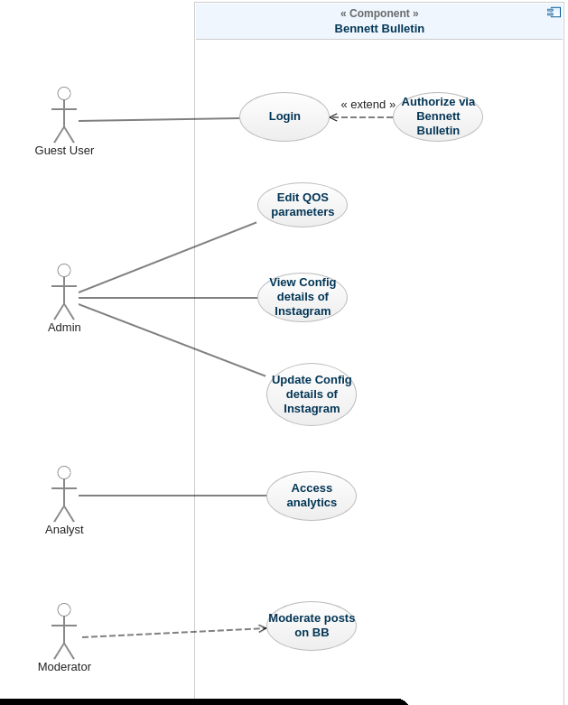

Figure 1: use-case diagram for BB

* + 1. **Entity Relationship Diagram**

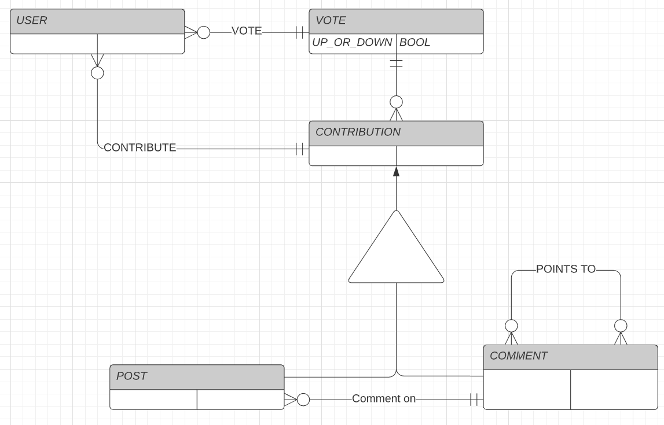

Figure 2: **ER diagram**

* + 1. **Class Diagram**

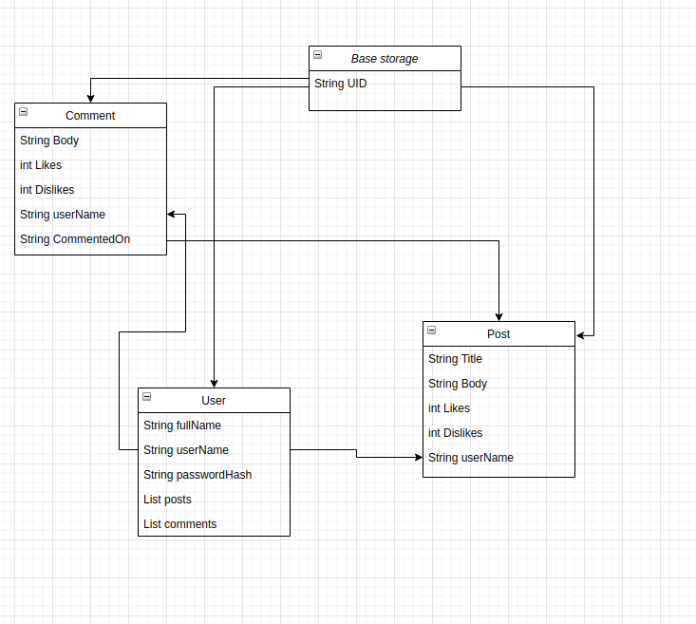Figure 3: **Class Diagram**

1. User Interface
   1. UI Description

Our project is based on MERN stack. So for the User Interface, we have used ReactJS to make the UI. We have a homepage where people can see posted content, write comments, like and dislike the posts. An add-post page has been implemented as well where people can create posts. The UI is a work in progress and we hope to implemet more features in the future. On the login page, we have an about us and contact us section where users can know about who we are and what we do before signing up on BB.

* 1. UI Mockup

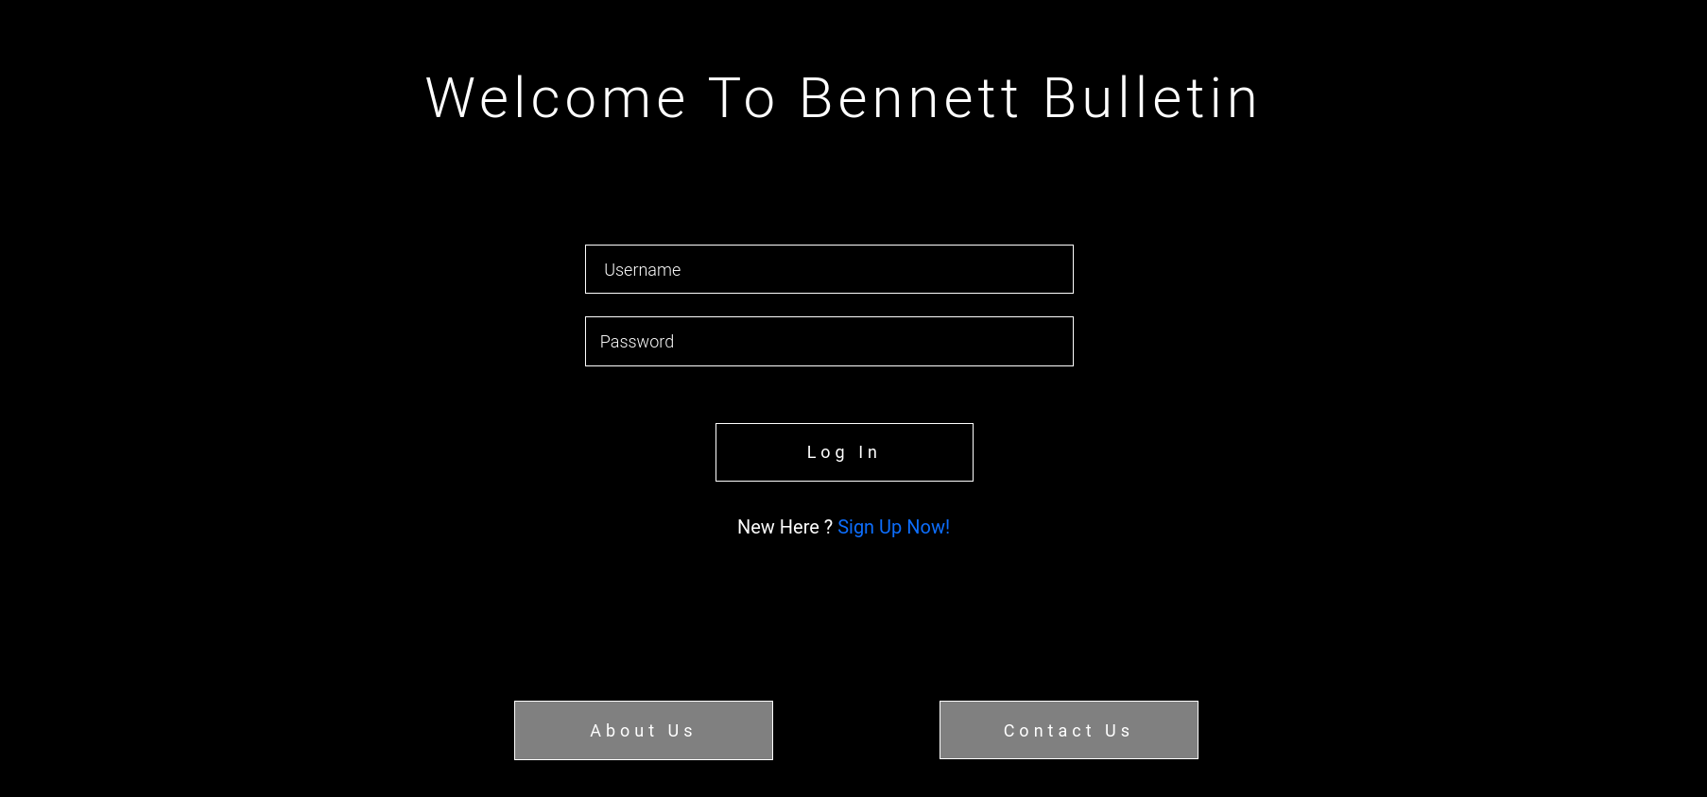

Figure 4: Sample 6

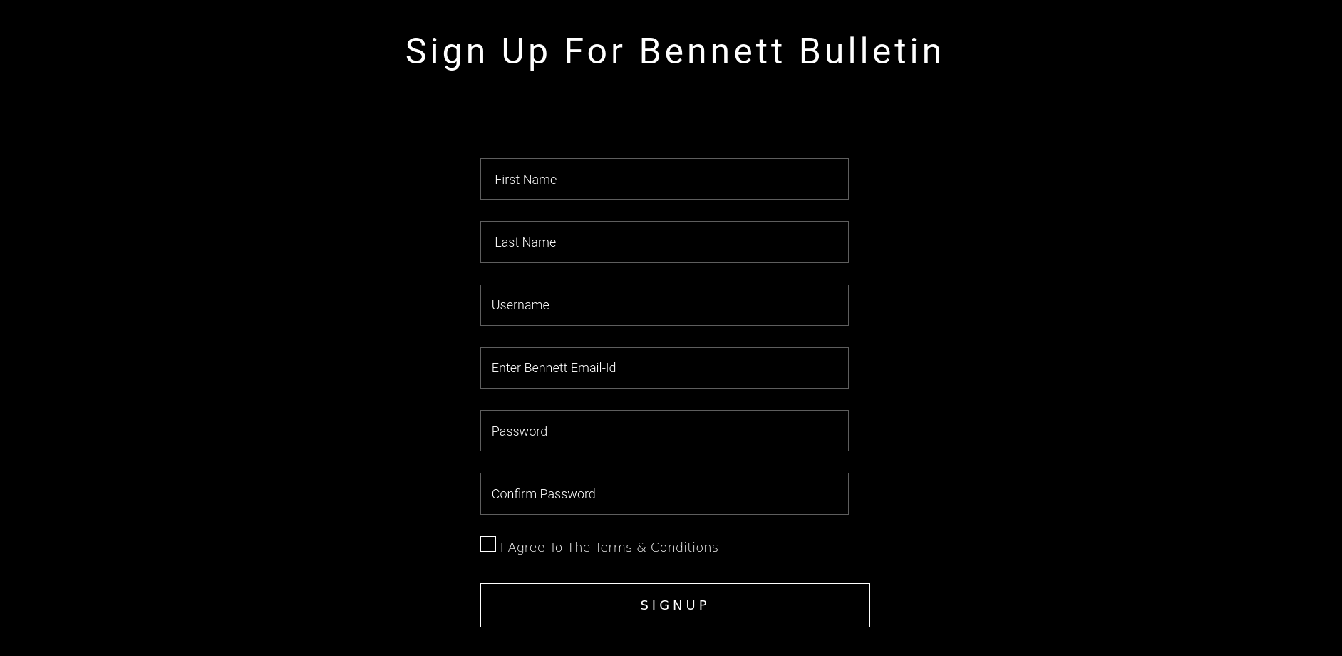

**Figure 5: Sample 7**

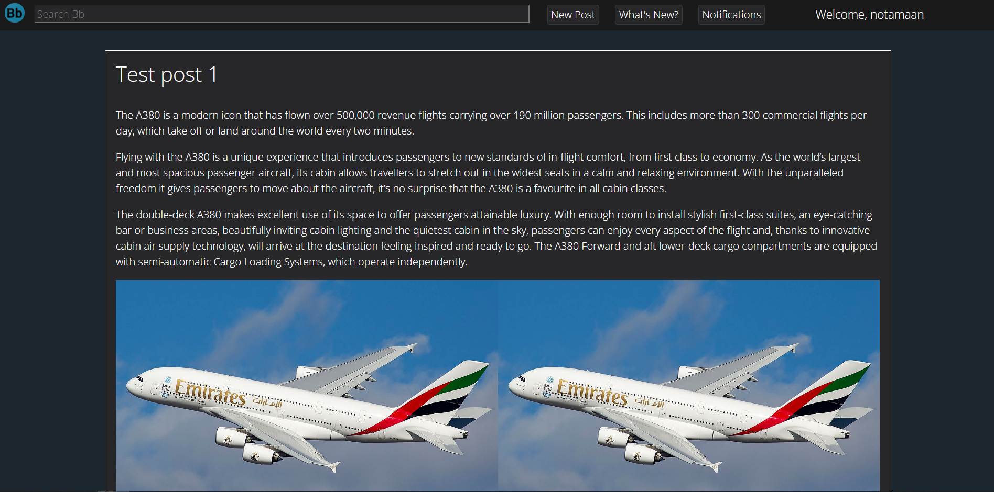

**Figure 6: Sample 8**

1. Algorithms/Pseudo Code

<<Include the proposed algorithm/pseudo code.>>

1. Project Closure

This section elucidates the overall lookup at the project and some of the future works that may enhance the solution.

* 1. Goals / Vision

Our original goals for this project were to create a web-based social media platform using the MERN stack (MongoDB, ExpressJS, ReactJS, NodeJS) exclusive to Bennett University students. During the course of this project, we realised the complexity of such a project and also realised we could also cater to other organisations as well. So, the main objective became making a working platform that could also be sold to other companies for a profit.

* 1. Delivered Solution

The solution that we delivered is a web-based social platform based on mern stack. mongodb, expressjs, reactjs, nodejs for the sharing of posts that contain images as well as text, and it also contains comments, likes and dislikes features. It is currently only for Bennett University students but can be modified as per the requirements for any other college or workplace.

* 1. Remaining Work

We have successfully created the working prototype for our application but we believe that it requires some polishing. We also want to create an android, ios app for the platform whoch would attract even more people towards the platform. The UI of our webapp has some features but we would like to implement some more like notifications, top posts, filters, search etc.

REFERENCES

<<Would suggest you to download a tool (Mendeley: [https://www.mendeley.com](https://www.mendeley.com/)) for automated citation and generation of references>>

1. T. Dillon, C. Wu and E. Chang, “Cloud Computing: Issues and Challenges”, 24th IEEE International Conference on Advanced Information Networking and Applications, pp. 27-33, 2010.

2. H. Casanova, et al. Heuristic for scheduling parameters sweep applicationsin grid environments, in: Proceedings of the 9th Heterogeneous Computing Workshop, HCW, pp. 349–363. 2009.

3. Kwok, Yu-Kwong, and Ishfaq Ahmad. "Static scheduling algorithms for allocating directed task graphs to multiprocessors." ACM Computing Surveys (CSUR) 31, Vol. 4, pp. 406-471, 1999.

4. A. Mutz, R. Wolski, Efficient auction-based grid reservation using dynamic programming, in: IEEE/ACM Int’l Conf. on Super Computing, SC 2007.

5. M. Mezmaz, N. Melab, Y. Kessaci, Y. C. Lee, E. G. Talbi, A. Y. Zomaya and D. Tuyttens, “Parallel Bi-Objective Hybrid Metaheuristic for Energy-Aware Scheduling for Cloud Computing Systems”, Journal of Parallel Distributed Computing, Elsevier, Vol. 71, pp. 1497-1508, 2011.

6. R. Buyya, C. S. Yeo, S. Venugopal, J. Broberg and I. Brandic, “Cloud Computing and Emerging IT Platforms: Vision, Hype and Reality for Delivering Computing as the 5th Utility”, Future Generation Computer Systems, Elsevier, Vol. 25, pp. 599-616, 2009.

7. Basements and crawl spaces. Retrieved from http://www.hud.gov/ offices/hsg/sfh/ref/sfhp1-25.cfm (Access in June 2020).